PROFESSIONAL TASK: COMPONENTS OF MARKETING PLAN
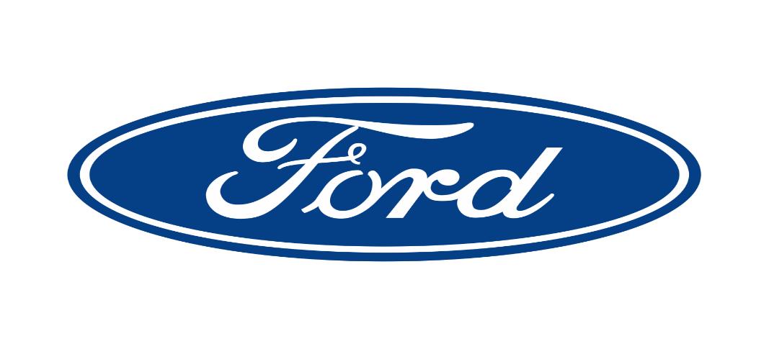

Executive Summary
The report also includes the assessment of the positioning of Ford and its product Ford Escape. The product was launched to be an elegant and sporty car. The car has attracted the attention of the customers, but it was not able to create a significant effect on the market. Here in the report, three metrics are chosen for analysing the problem in the marketing activities that led to the poor performance of Escape in the Australian market. It is found that although the car was able to generate significant sale initially, it failed to maintain the persistence later. The three metrics that are used include sales growth, leads and marketing contribution to revenue. The car was not able to make expected leads. The management was also not satisfied with the revenue it generated. Ext the target market I also analysed. The firm mainly used demographic, geographic and psychographic segmentations for deciding the target market of Escape. Primarily millennial are targeted. The report included a positioning map and perceptual map to identify the perception of the company and that of the customers. Finally, the brand equity of Ford Escapee and the entire organisation has been discussed. Three recommendations are offered that suggested for improving the target marketing strategy and better interaction with the customers.

Table of Contents
Introduction 4
1.0 Effectiveness of marketing practice 4
2.0 Target market 6
3.0 Positioning 7
3.1 Positioning Map 7
3.2 Positioning Statement 8
3.3 Perceptual Mapping 9
3.4 Overview of Performance 10
5.0 Brand equity 10
Recommendations 12
Conclusions 13
References 14

Introduction
The purpose of the report is developing an action plan for enhancing the marketing performance of Ford in terms of promoting the car named Ford Escape. Hence, it involves analysing the issues Ford Escape is facing. Behind the success of any product, significant marketing effort is compulsory. Therefore, in this report, three metrics for analysing the effectiveness of the marketing practices of Ford are identified and discussed. Next, a profile of the target market for Ford Escape is discussed that is approached for buying the product. In the next part, a positioning statement is developed along with a positioning map. Lastly, the brand equity of the firm regarding the Ford Escape is analysed. Based on these analyses, final recommendations are developed.
Ford Motor Company of Australia Limited or Ford Australia is Ford Motor’s subsidiary that was established in 1925 in Victoria, Australia. The company is headquartered in Michigan U.S. It designs, contrives and imports cars, truck and SUVs with leading fuel economy, technology, quality and safety (Ford Australia, 2019). The Ford Escape is comparatively a new model that substituted the Ford Kuga in 2016. A medium SUV competes with the Honda CR-V, the Hyundai Tucson and the Toyota Rav4 (CarAdvice, 2019a).

1.0 Effectiveness of marketing practice
Assessment of the effectiveness of marketing activities is the first step results in control and finally to development for any person trying to take their marketing determinations to the subsequent level. For marketers, metrics give a deep understanding of the acceptance of the product that is marketed and its performance. Gaining insight into what is useful and what is not in marketing activities, key performance metrics are a vital part of the growth strategy. Several marketing metrics are there that have some applicability to the marketing activities. These metrics help in analysing the areas of marketing activities that need improvement for ensuring effectiveness (Kotler et al. 2017). Hence, the following parameters can be part of the marketing dashboard for the Ford Escape:
1. Sales growth- This is the best method of examining marketing success that involves assessing the progress in sales revenue. Once, a marketing manager starts exploring the effect of marketing on sales growth, and it initially needs some adjustment to remove the marketing, which does not drive sales (Chaffey and Ellis-Chadwick, 2019). Ford can apply these metrics for analysing the effectiveness of its marketing activities for promoting Ford Escape. In 2018, the car was a persistent earner for Ford Australia. However, the volume is decreased by 63% accounts to 4373 units (Hilliard, 2019). Thus, the decline in sales rate proves the inefficiency of the marketing activities carried out by Ford in Australia. Ford adopts advertising as its vital marketing strategy. The online advertisement and TV advertisement are especially famous. Although, initially Ford Escape was able to generate a notable sales rate, however, due to lack of competency of the marketing activities, later the sales rate decreased.
Tuten and Solomon (2017) stated that analysing sales growth is essential to the benefit of the firm in the long run. It did not just play the role of useful metrics in strategic planning, but also enables for finding out the development trends.
2. Leads- According to Hastings and Stead (2017), the edge is a simple sum. The more points a company obtains the more sales prospects it has that increases the opportunity for sales rise. The significance of leads to the sales department and marketing is similar to the value of something such as an automobile. Points drive them. An MQL or marketing qualified lead is a lead examined more possibly for becoming a customer likened other leads by lead intelligence. MQLs are sales-ready and highly engaged contacts comparing to the standard points, however, who have not become wholly fledged chances. On the other side, a SQL or sales qualified lead is that the sales team has considered as the earnest of a follow up of direct sales. They have been examined much more and denote an opportunity, which is readily making a decision. In March 2013, Ford Escape got the lead of 24110 units. In 2016, after rambling the Honda CR-V for several months, Escape dragged ahead for May again. The redeveloped model in 2017 is expected to boost sales (Sanchez, 2019). Hence, the leads suggest that the marketing activities of Ford Escape were initially active. Direct selling, personal selling, sales promotions and public relations worked well that increased leads. However, later they become ineffective due to lack of focus.
3. Marketing contribution to revenue- The higher the percentage of income of the entire company, the more it proves the efficiency of the marketing efforts (Hastings and Stead, 2017). Therefore, looking at the revenue come from the sales of Escape can help in examining the effectiveness of the marketing activities. It is found that the regional boss of Ford is much dissatisfied with the uncertain sales of Escape SUV in Australia to continue the record about it (CarAdvice, 2019b). Thus, it indicates that the marketing functions or strategies adopted by Ford are unable to drive sales as per the expectations.

2.0 Target market
A target market refers to a group of customer most possibly to purchase the products or services of a company. The customers generally want to shop the offerings of a company that need their needs most appropriately. Therefore, a company must target a specific set of customer instead of targeting everyone for a particular product. The company should develop strategies for approaching that specific group of customers, as it is the most effective approach (Chaffey and Ellis-Chadwick, 2019). Hence, rather than targeting all the Australians for the Ford Escape, Ford targets a particular segment of customer. De Mooij (2018) commented that for segmenting customers, several factors are there that need to be considered are geographic, demographic psychographic and behavioural. These are the main categories of segmenting customers.
Ford targets the profitable local SUV market for its Escape cars. Ford uses a combination of demographic, geographic and psychographic segmentation for catering the changing customer needs. The company uses a unique targeting strategy for providing particular products to specific customer segments. The segmentation variable stimulates the decisions of Ford and the way it places and positions its products within the Australian market. Geographic segmentation considers the factors such as living place of customers, topology, climate and the urban, rural or suburban characteristic of the area. For the Ford Escape, the company mainly targets people living in Western Australia. The demographic features include sex, age, income, household composition and income. The Escape targets mostly male customers who belong to the age group of 26-37 years. The psychographic segmentation contains attitudes, personality, lifestyle and motives, Roy Morgan values and their VLAS characteristics. Ford focuses on putting its advertising effort on a customer segment that is most worthwhile including young males, who live life actively and need a sturdy vehicle. The company attracts the millennial and young professionals for using the car. Next comes the behavioural characteristics that mainly comprises of the frequency of buying of customers, customer loyalty and others (Forbes, 2019).
The advantages of customer segmentation for Ford is broad. The company can design an advertisement campaign, which is mainly targeted at the selected customer segment. Targeted advertising is useful, as postnatal customers can find the message of the advertising pertinent to them. For instance, if the ad is to demonstrate an old man of 60 years as the representative for an Escape, it may be irrelevant and ineffective. Therefore, by creating an appropriate advertising campaign that targets millennial is an effective way of targeting people. Money can be saved on advertising. If Ford develops an advertisement that is targeted to attract a specific segment, they can also establish the image of the car. It also improves efficiency, as there is lower wastage of time, funds and efforts. Developing a focused and that considers the particular customer segment, which understands and can connect to instead of 10 ads that have slight relevance to the market causes confusion. Further, the company can monitor the changes within a particular segment easily by hiring a team for doing it. They can better foretell and anticipate the changes, particularly within the sector. The car manufacturing industry and the choice of customers are profoundly affected by the microenvironment and macro-environmental forces. For instance, if the targeted segment is projected to be affected by the adverse economic conditions and sales of escape is expected o decline, Ford can respond toward it timely.

3.0 Positioning
Gower et al. (2010) commented that positioning is the place that the firm wants to occupy in the minds of the customers and also the true perception of the consumers on the brand and its products. Ford has always focused on positioning its brand as the ‘car of the next century'. Its iconic brand logo stands for the legacy and its assurance towards integrity. Its product Ford Escape was introduced in Australia in 2016 by replacing Ford Kuga in the year 2016 (Oster, 2019). This product was launched to enhance its positioning and offer tough competition to Toyota, Hyundai and Honda cars.

3.1 Positioning Map
Ford has always focused on placing its brand and product in such a way so that it is able to attract the attention of the customers. The positioning map below identifies the ways in which Ford wishes the customers perceive the brand as well as its product Ford Escape:
Elegant
Sporty
Dependable
Affordable
- Toyota RAV4
- Honda CRV
- Chevy Tracker
- Hyunda Santa Fe
- Subaru Outback
- Subaru Forrester
- Mazada MX5
- Ford Escape
Figure 1: Positioning map of Ford Escape
(Source: Oster, 2019)
Ford Escape was launched to uphold the position of the brand. It was an SUV with sports car design and features which were meant to increase the sales and market share. This would help to increase customer loyalty and create a competitive advantage in the market. Ford has focused on brand development through the Ford 2000 Globalisation plan that has enhanced the ability to capture equity and brand essence (Oster, 2019).

3.2 Positioning Statement
Ford has been launching cars with a specific personality that has helped to change the perception of the customers and has refreshed its brand image. The positioning statement of the brand is illustrated below:
‘For the speed lovers and youngsters, the Ford offers the best experience of the journey with advanced technology and design among all car manufacturers because Ford is ranked second best brand in Consumer Report and is known for its integrity and legacy.'
As per the Consumer Reports 2012, Ford is the second best brand after Toyota with a score of 121 as per the perception of the customers (Consumerreports, 2015). The campaign of ‘Built for Proud’ clearly reflects the above positioning statement that showcases Ford Escape that compactly include the features of SUV in a car for offering the best experiences to its customers.

3.3 Perceptual Mapping
Ford has been considered to be the second best brand by the consumer. However, its performance has declined with a fall in the market share. Ford has tried to maintain its brand position. However, the perceptions of the customers have changed as is evident in the images below:
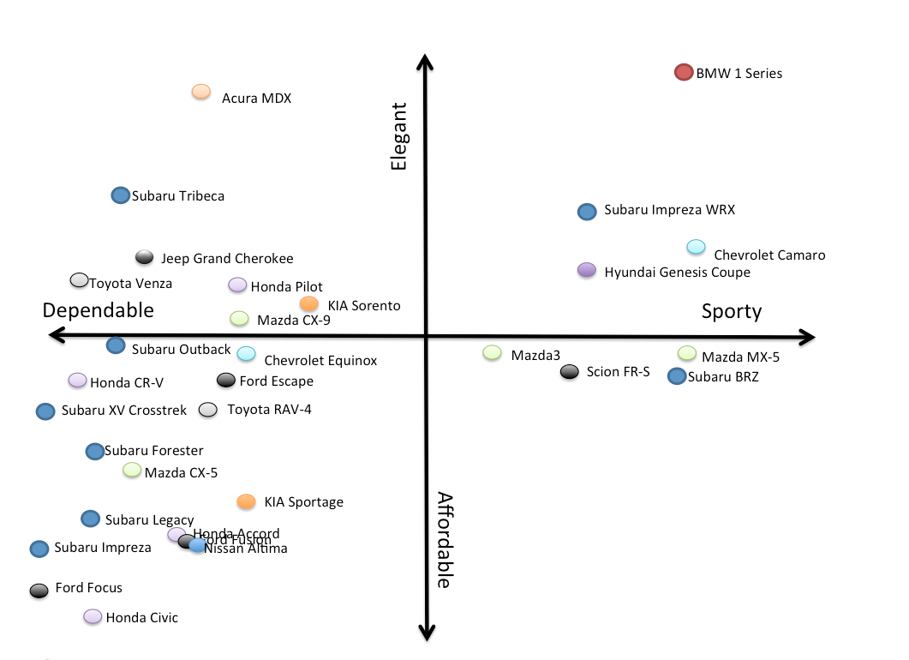
Figure 2: Perceptual Mapping of Ford
(Source: Selwyn, 2019)
Ford is considered to be an affordable but dependable band. The customers prefer the brand, but presently the brand is not able to provide something unique to the customers. Since the year 2017, the brand has seen a drop in sales that has affected its market share. The market share of Ford is 6.8% in Australia, and it recorded a decline of 4.5% (Selwyn, 2019). The improper positioning of the brand and limited focus on innovation has resulted in the changes in the perception of the customers.

3.4 Overview of Performance
Ford was able to develop the appropriate strategy in the recession by segregating and targeting its market, refreshing the brand positioning and making an investment for developing small cars and fuel-efficient engines (Forbes, 2019). Ford focuses more on outdated models made the competitors grasp the market share. However, Ford Escape was a drive into SUV a sporty feeling and personality (Conlon & Perkins, 2018). It created tough competition for Volkswagen and Toyota. The sales increase and Ford recorded a profit of $27 million in the year 2017. The total number of vehicles which was sold by Ford was 78,161 in Australia in the year 2017. The market share was 6.6%, and it presently occupies the sixth position in the best selling automotive brands. For increasing its profitability and offering a new experience to the customers, the brand is investing heavily on research and development which accounts for $471.5 million annually. 2018 Ford Escape has not yet attracted the customer, but the brand needs to position it effectively (Forbes, 2019).

5.0 Brand equity
Theurer et al. (2018) commented brand equity as the commercial value which is obtained from the perception of the customers regarding a particular product. The analysis and the measurement of the brand equity require the brand knowledge followed by the perception and the responses of the customers on the specific product of a brand.
Ford is one of the renowned brands in Australia vehicle industry. Ford Escape has incorporated the new technologies related to designs and engineering. Ford Escape was launched with the active patents that have helped to attract the customers. Ford Escape has helped to create positive word of mouth and created awareness in Australia (Kantar & Bardakci, 2017). However, Ford still lacks the appropriate brand architecture, and this has failed to attract the customers. The Brand Equity of Ford has been illustrated below:
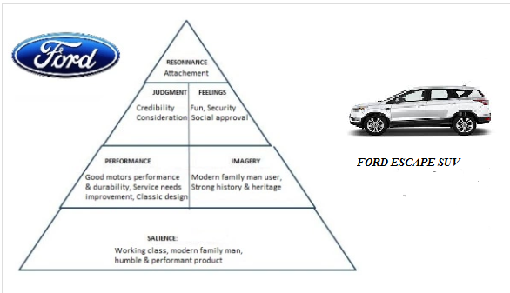
Figure 3: Brand Equity of Ford Escape
(Source: Ford Australia, 2019)
Ford Escape is a sporty car, but it was affordable and was designed for the middle-class people of the developed countries like Australia and the UK. Ford Escape was a humble product that combines modern technology and the features of Sporty car in an SUV. The design is modern and attractive and hence targeting the young generation. The features are efficient with the classic design incorporating the features of the sporty design. Ford Escapee enhances the feeling of fun and help in creating social recognition with its attractive designs and features (Ford Australia, 2019). The product was able to create an attachment with the customers, and this is effective in the increase in the sales of the company and also the increasing market share. Ford needs to improve its brand architecture for increasing customer awareness about the product and regain its position in the Australian market.
The brand equity of Ford Escape can be better understood with the basic scored which helps to evaluate the performance of Ford as a brand (The Economic Times, 2019):
- Brand Awareness of Ford is 90%
- Perceived quality of Ford Escape is 83%
- The brand Association of Ford is 47%.
- The brand loyalty of Ford is 41%
The above measurement clearly helps to assess the current performance of the brand Ford. Ford Escape has definitively proved to be fruitful for the organisation by increasing the sales and the market share of the organisation.
The brand value of Ford is currently $30bn. The brand has a long-standing history which has created a strong brand name. Ford Escape was able to uphold the brand name with its technology and designs. The product is able to create a trusted brand with its reliable and safety features (The Economic Times, 2019). As per the researches, the customers are able to assess the improvements made by the brand in the car. However, the brand needs to improve its positioning strategy to reach out to the customers and changing the perception of the customer is quite time-consuming.

Recommendations
- Better Identification of the target market: The demographic structure of Australia has changed over time and so the purchasing decision making of the consumers. Ford needs to better understand its market by identifying the needs and the wants of the customers. The segregation of the market segment would help to assess the market segment of the customers and develop the targeting strategy accordingly. Thus, Ford would innovate the cars as per the needs of the customers and prices would be set accordingly.
- Improving positioning by identifying more with customers: Ford need to develop a positioning strategy that would be realistic, and the customer can better identify themselves with the product. Ford can develop the campaign for product positioning in which the common people can be included instead of involving the celebrities or great personalities. Ford needs to position itself better for reaching out to the customers and influencing them to purchase the new products launched by the brand. This would help to increase customer loyalty and create a competitive advantage in the market.
- Better Interaction with the customers: Ford needs to increase its interaction with the customers. The prime reason for this is that it would improve the marketing activities of the organisation and enable ford to connect with the customers. The identification of the needs of the customers is essential, and this can guide Ford to develop the marketing mix elements. The interaction with the customers is essential for increasing loyalty and thereby gets back the market share.

Conclusions
The present report explored the current marketing position of Ford. The marketing position of Ford has been discussed with special reference to Ford Escape. The report has identified the three marketing metrics to assess the shortcomings of the organisation. This was followed by the assessment of the target market of Ford. The positioning strategy of Ford has helped to identify important aspects of the organisation. The organisation has seen a decline in the sales and market share in Australia. However, Ford Escape helped to increase sales in 2018. Ford Escape is a sporty car, but it was affordable and was designed for the middle-class people of the developed countries like Australia and the UK. Ford needs to improve its brand architecture for increasing customer awareness about the product and regain its position in the Australian market

